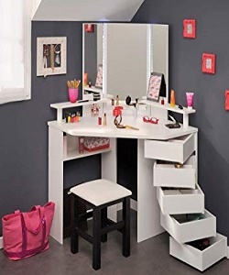

Stylish Dressing Table

$228.75

Availability: In stock

**Description:**

White Corner Dressing Table with Lights, Mirror, 5 small drawer nd one hite sitting stool.  The finish and contemporary design are adaptable for any decor style. It is perfect to prepare yourself for a day of work or important date at night. One storage drawer provide sample hidden storage space for small items. Available with us at highly affordable market prices, these Dressing table are available in customers stated specifications.